STATEMENT OF PILGRIM & ASSOCIATES
REGARDING
FINDINGS & RECOMMENDATIONS OF
UNIVERSITY OF NEW MEXICO CLIMATE ASSESSMENT ON
SEXUAL VIOLENCE IN STUDENT RESIDENTIAL HOUSING & ATHLETICS PROGRAMS

January 22, 2015
Albuquerque, New Mexico

Pilgrim & Associates (P&A) was pleased to assist the University of New Mexico in better understanding the climate and attitudes on campus with respect to sexual violence. As an independent and objective collector and evaluator of the attitudes and perceptions of UNM students and staff on this critical and controversial topic, P&A was able to provide the university with critical data and information to support and guide existing UNM initiatives in this area, while also providing feedback on areas of focus for improvement and further action.

In sum, P&A determined that UNM takes very seriously its obligation to safeguard its students and staff from discrimination, specifically sexual violence. This was evidenced by student and staff educational and training initiatives related to preventing sexual violence, as well as the formation of the Presidential Task Force on Sexual Violence, among other activities. However, P&A also identified a number of areas in which UNM should focus special attention and seek improvement. P&A was encouraged that, even as the climate assessment was underway, UNM was simultaneously implementing improvements to its responses and handling of sexual violence incidents, as well as preventive measures.

Key Findings

- Students, staff, and administrators recognize that UNM is making a commitment to education and prevention programs related to sexual violence and generally feeling safe.
- UNM students are aware of the issue of sexual violence and generally feel safe.
- UNM staff and administrators are generally unfamiliar, unclear and confused about the UNM policies and procedures to address sexual violence.
- UNM students are generally unfamiliar, unclear and confused about the UNM policies and procedures to address sexual violence.

FINDINGS RELATED TO STUDENT RESIDENTIAL HOUSING

- Staff and administrators acknowledge the seriousness and importance of issues surrounding sexual violence, and are confident in their ability to recognize and address such incidents.

- Students living in UNM feel safe and believe that there are only limited incidences of sexual violence.

FINDINGS RELATED TO UNM ATHLETICS PROGRAM

- Staff and administrators believe that student athletes are no more likely to be involved in acts of sexual violence than other areas of the university or the general student body.
- UNM student athletes are generally aware of sexual violence and concerned that they are stigmatized as a group by the inappropriate actions of a few.
- UNM student athletes feel safe with respect to sexual violence.

FINDINGS RELATED TO UNM POLICIES & PROCEDURES ON SEXUAL VIOLENCE

- In the fall of 2014, UNM had 17 policies in place relevant to incidents of sexual violence.
- Several of UNM policies do not comply fully with the dictates of Title IX of the Education Law, and related guidance issued thereunder.
- Many of the procedures to redress sexual violence complaints are not fully compliant with the dictates of federal law.

P&A also found areas requiring further attention and offered suggestions for UNM with respect to implementing innovative programs, improvements in policy-making and procedural processes, and corrective measures to reduce the likelihood of the negative impacts and consequences of incidents of sexual violence in its residential housing and athletics program.

Recommendations & Suggestions:

- Simplify policies impacting sexual violence to create an accurate, user-friendly and easily accessible sexual misconduct policy, applicable to students and employees.
- Ensure, through fair and due process, both the alleged victim and alleged perpetrator have equal opportunity to enjoy the benefits of their education
- Improve security environment to reduce the possible occurrence of sexual violence incidents.
- Ensure that ongoing sexual violence training is expanded to all constituency groups, and is consistent, coordinated and compliant with federal law in content.
- Intensify the aspect of the sexual violence training’s emphasis on its obligations to prevent and report incidents of sexual violence, as well as the significance and distinction between which UNM staff are mandatory reporters and those who can maintain information as confidential.
- Take all steps necessary to remove any and all real or perceived obstacles that could prevent students, faculty or staff from reporting an incident of sexual violence.
- UNMPD seeks means of improving visibility and effectiveness as preventive measure.
- Seek enhanced means of safeguarding the well-being of UNM students both on-campus and off-campus.
- Extend education and training of students on sexual violence prevention throughout a UNM student’s college experience.
- Expand working relationship with Rape Crisis Center of Central New Mexico (RCC) and NAACP.

COMPARATIVE DATA

UNM’s reported incidents of sexual assault appear consistent with those of similarly-sized universities.

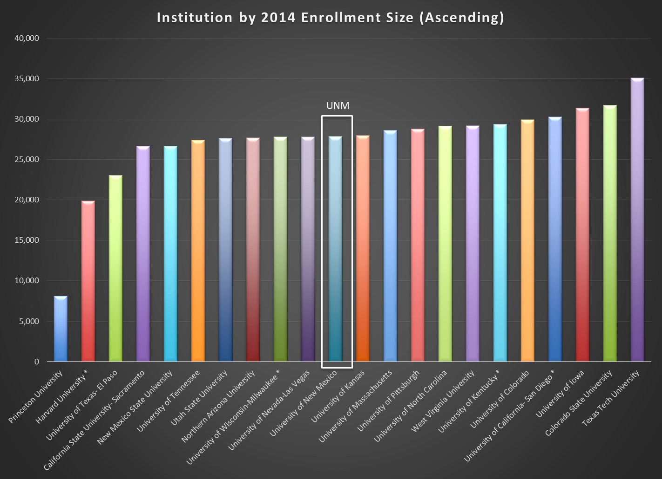

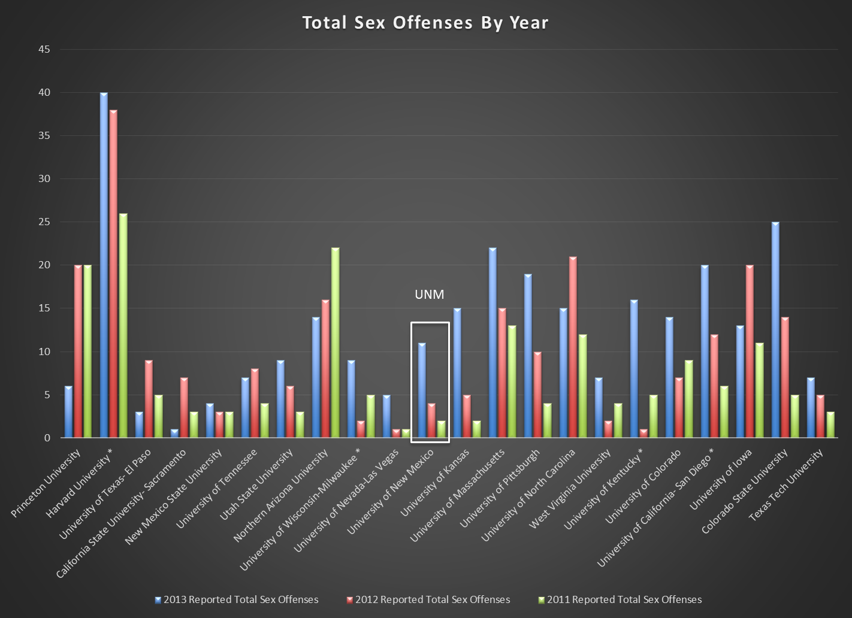
(12 Higher, 9 Lower than UNM)

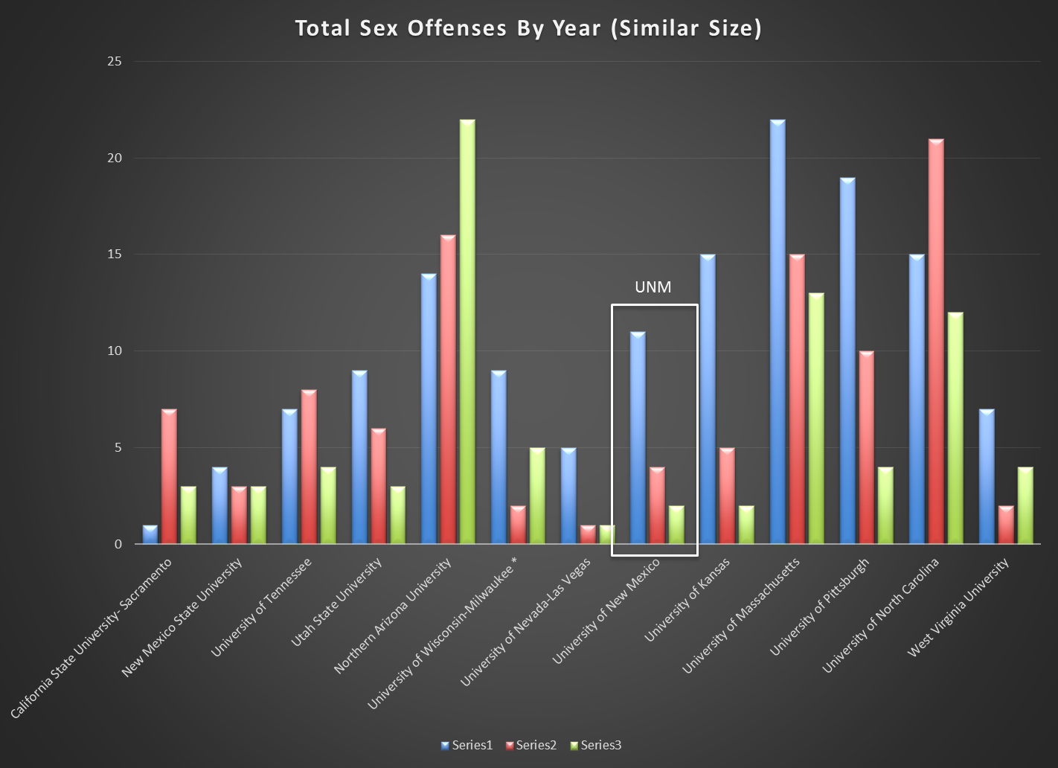
(5 Higher, 7 Lower than UNM)

Most Sexual Violence Incidents on Campus and in Student Housing
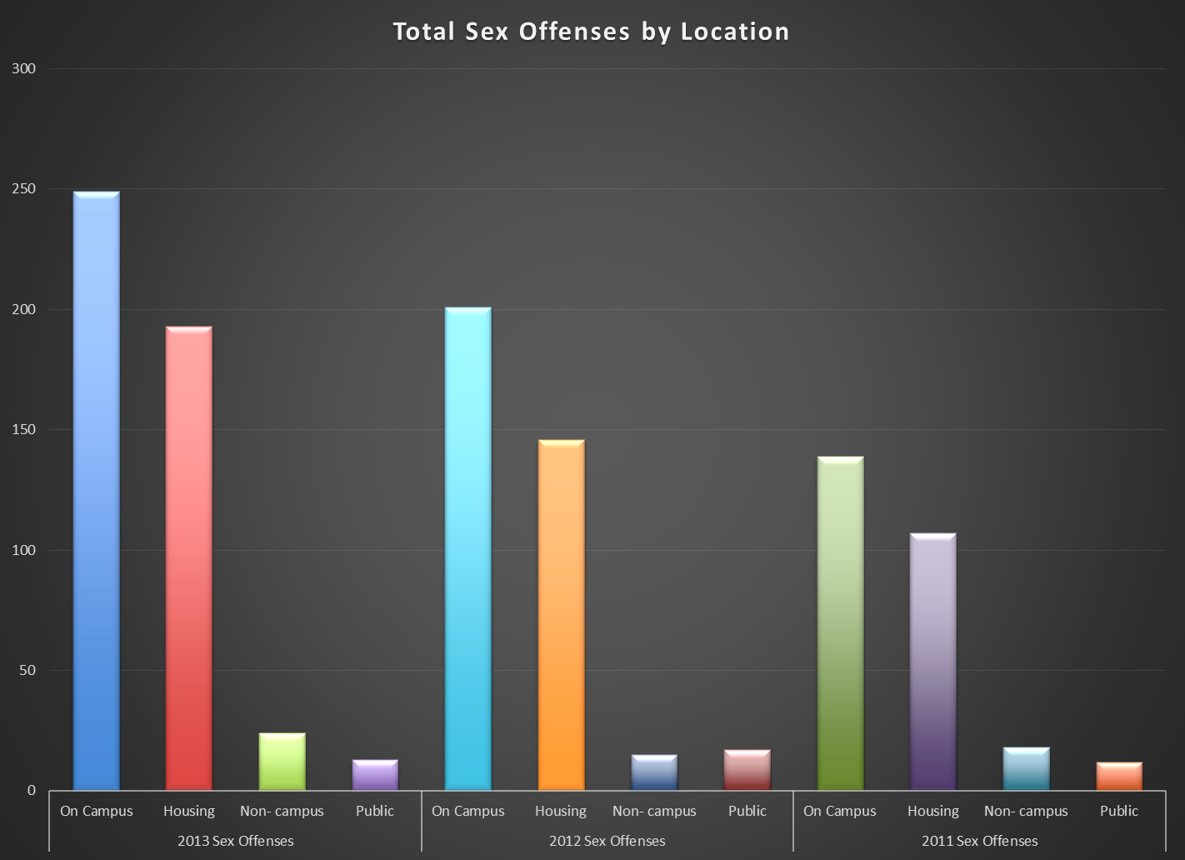
(Excludes University of New Mexico)

Most Sexual Violence Incidents on Campus and in Student Housing

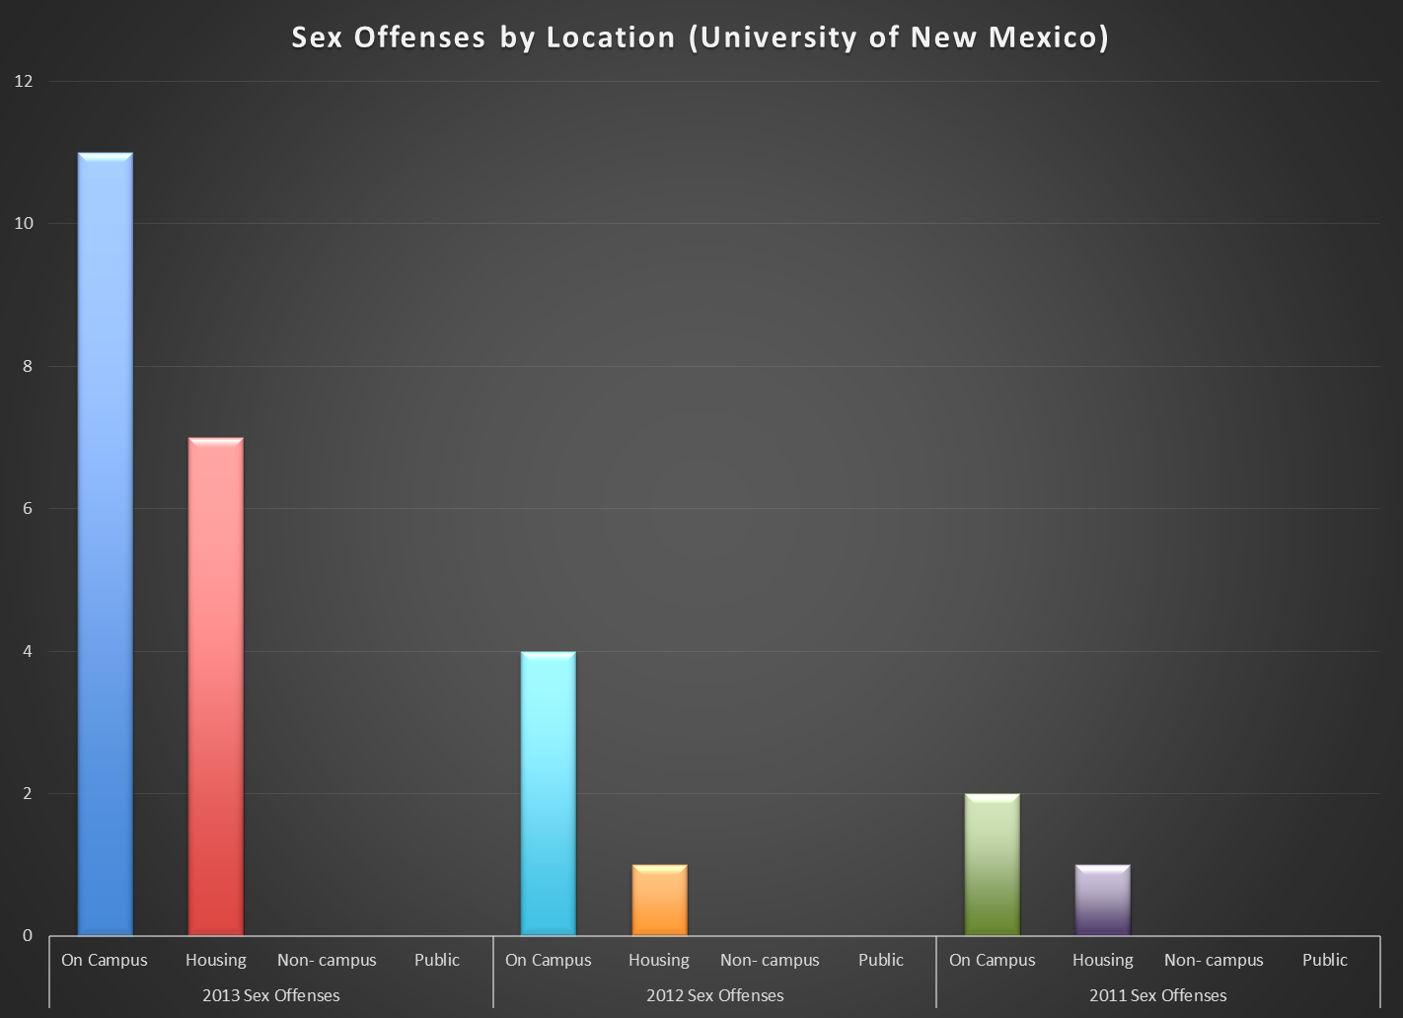

Jill Pilgrim, Esq.
Pilgrim & Associates
jpesq@pilgrim-associateslaw.com

